

Executive Summary:

The provided summary offers an insightful glimpse into the toolkit available for programming the Xbox Series X platform. The Xbox Series X Software Development Kit (SDK) serves as the cornerstone for Xbox Series X programming, offering a comprehensive set of tools and resources tailored for creating games and applications for this next-gen console. Key components of this toolkit include the Xbox Development Kit (XDK), providing libraries, APIs, and tools for development, debugging, and asset management. Visual Studio, a widely used integrated development environment (IDE), supports various programming languages like C++, C#, and DirectX, streamlining game development and debugging on the Xbox Series X platform. The Xbox Live SDK seamlessly integrates features like multiplayer matchmaking, achievements, leaderboards, and user authentication into developed applications. DirectX 12 Ultimate, a robust collection of APIs, empowers developers to create graphics-intensive applications, tapping into the Xbox Series X's hardware capabilities. Prominent game development engines such as Unity and Unreal Engine offer Xbox Series X support, including Xbox-specific integrations and assistance with visual scripting and languages like C# and C++. The Xbox Dev Mode allows conversion of standard retail Xbox Series X consoles into development kits, facilitating application deployment and testing directly on the Xbox Series X hardware. To succeed in programming on this advanced gaming platform, developers are encouraged to fully utilize official Xbox Series X developer documentation and resources, which include tutorials, sample codes, and community forums. The collective power of the Xbox Series X SDK and its accompanying tools empowers developers to craft captivating and immersive experiences for Xbox Series X users. Recognizing the platform's potential and adopting best practices are essential for maximizing the Xbox Series X's capabilities and delivering quality content to a global audience.



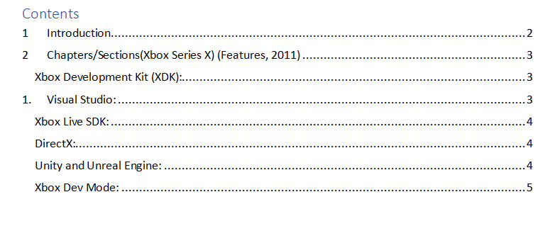

# 3.png

# Introduction

Programming for the Xbox Series X platform involves utilizing a range of tools tailored to create immersive experiences for users. This response delves into the tools available for Xbox Series X programming, offering insights into their functionalities and advantages. It also addresses the physical attributes of the Xbox device, the Xbox Development Kit, available help and tutorial materials, and includes a comprehensive bibliography for reference. (Xbox, 2011)

# Chapters/Sections(Xbox Series X) (Features, 2011)

Xbox Development Kit (XDK): This section will explore the Xbox Development Kit, which includes libraries, APIs, and tools necessary for creating games and applications for Xbox consoles. It will cover the development environment, debugging capabilities, performance analysis, and asset management features provided by the XDK. (XDK, 2020)



Figure

# Visual Studio:

This section will discuss the use of Visual Studio as an integrated development environment (IDE) for Xbox programming. It will highlight how Visual Studio supports multiple programming languages such as C++, C#, and DirectX, making it easier to develop and debug games for the Xbox platform.

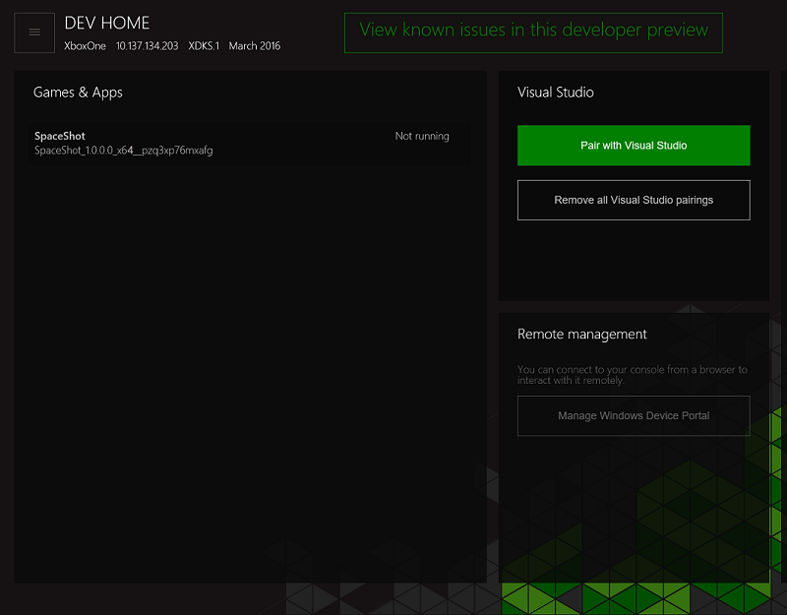

Figure

Xbox Live SDK: This section will focus on the Xbox Live SDK, which enables developers to integrate Xbox Live features into their games and applications. It will cover features like multiplayer matchmaking, achievements, leaderboards, and user authentication.

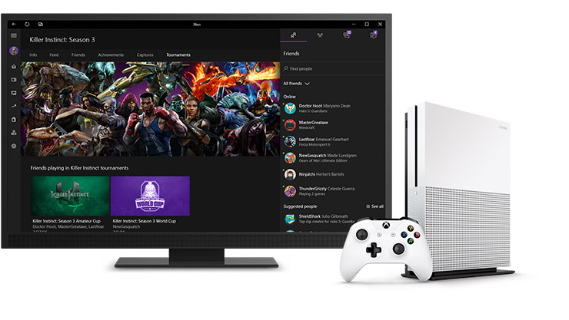

Figure

DirectX: This section will explore the role of DirectX in Xbox programming. It will discuss how DirectX, a collection of APIs, allows developers to create graphics-intensive applications, including games, for the Xbox platform.

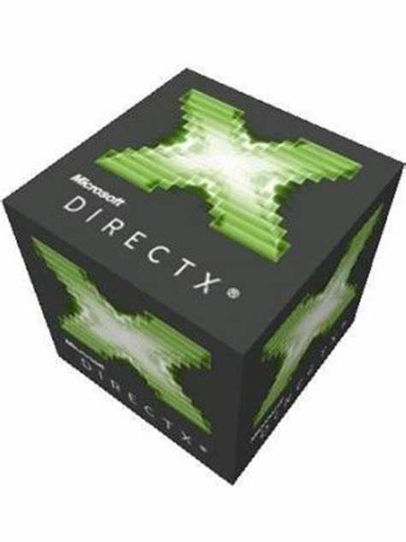

Figure

Unity and Unreal Engine: This section will discuss the use of Unity and Unreal Engine as popular game development engines that support Xbox development. It will highlight how these engines provide Xbox-specific integrations and support visual scripting or programming languages like C# or C++.



Xbox Dev Mode: This section will explain Xbox Dev Mode, which allows developers to transform their retail Xbox consoles into development kits. It will discuss how enabling Dev Mode on the console enables deployment and testing of games or applications directly on the Xbox hardware.

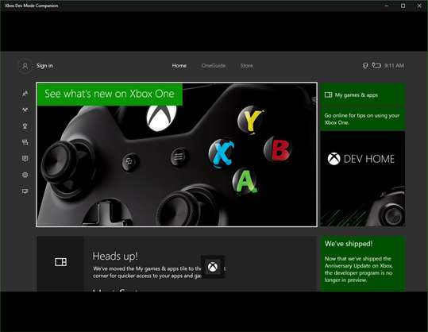

Documentation and Online Resources: This section will emphasize the importance of utilizing the official Xbox developer documentation, tutorials, and online resources. It will provide information on accessing resources, sample code, and community support through the official Xbox Developer website.



Limitations (optional): This section, if included, will discuss any limitations or challenges developers may encounter when programming for the Xbox. It may touch upon factors such as hardware constraints, certification requirements, or specific platform restrictions.

# Physical aspect of the device: (list, 2020)

The physical aspects of the Xbox device refer to its hardware components and design. Here are some key aspects of the physical features of the Xbox consoles:

Console Design: Xbox consoles are designed as sleek and compact devices. They typically have a rectangular shape with smooth edges. The design may vary between different Xbox console models.

Ports and Connectivity: Xbox consoles include various ports for connecting peripherals and accessories. Common ports found on Xbox consoles include USB ports for connecting controllers, external storage, or other devices, HDMI ports for video and audio output to a TV or monitor, Ethernet ports for wired internet connectivity, and optical audio ports for connecting audio systems.



Power and Cooling: Xbox consoles require a power supply to operate. They are equipped with internal cooling systems, including fans and heat sinks, to regulate the device's temperature and prevent overheating during extended gaming sessions.



Controllers: Xbox consoles come with wireless controllers that have a specific design and layout. The controllers feature buttons, thumbsticks, triggers, and other input mechanisms for interacting with games and navigating the console's user interface. (controller, 2023)



Storage: Xbox consoles include built-in storage for installing games, apps, and system software. The storage capacity may vary depending on the console model. Some Xbox consoles also support external storage options, allowing users to expand the available storage space using external hard drives or solid-state drives. (know, 2013)



Disc Drive: Many Xbox consoles have an optical disc drive that supports physical game discs and media playback. However, newer models, such as the Xbox Series S, may come without a disc drive, relying solely on digital downloads and streaming. (drive, 2022)



Display Output: Xbox consoles support high-definition video output, with resolutions up to 4K or even 8K, depending on the model. They also support HDR (High Dynamic Range) for enhanced visual quality and may offer advanced features like variable refresh rate (VRR) and Auto Low Latency Mode (ALLM) for smoother gameplay.



Accessories: In addition to the standard wireless controller, Xbox consoles support various accessories, including specialized controllers, headsets, charging docks, and other peripherals designed to enhance the gaming experience.



# The Xbox Development Kit includes:

The Xbox Development Kit offers a suite of indispensable resources, such as libraries, APIs, and development environments. These components facilitate graphics rendering, audio processing, input management, networking, debugging, performance analysis, asset management, and the certification and publishing of applications.

Libraries and APIs: The XDK offers a collection of libraries and APIs specifically designed for Xbox programming. These libraries provide access to various functionalities and features of the Xbox platform, such as graphics rendering, audio processing, input handling, networking, and more.

Development Environment: The XDK provides a development environment that includes tools for coding, debugging, and testing Xbox programs. It offers features like code editing, project management, and build configurations to streamline the development process.

Debugging and Performance Analysis: The XDK includes tools for debugging Xbox programs, allowing developers to identify and fix issues in their code. It provides features like breakpoints, step-through debugging, and real-time performance analysis to optimize the performance of games and applications.

Asset Management: The XDK provides tools for managing game assets, such as textures, models, sounds, and animations. These tools help developers efficiently import, organize, and optimize assets for use in Xbox programs.

# Certification and Publishing Tools:

The XDK includes tools and guidelines for certifying Xbox games and applications. These tools help developers ensure that their programs meet Microsoft's quality standards and can be published on the Xbox marketplace.

# Help/tutorial materials available:

Developers benefit from a plethora of support materials for Xbox programming. These encompass the official Xbox Developer Documentation, the Xbox Developer YouTube Channel, the Xbox Developer Forums, Microsoft Developer Blogs, Unity Learn, Unreal Engine Documentation and Community, and third-party tutorial websites and communities. These resources offer valuable insights, tutorials, and interaction with fellow developers.

Socio-technical Issues Perspective: Programming for the Xbox Series X also prompts contemplation on the socio-technical ramifications of gaming technology. The transformative impact of gaming technology on the gaming industry and user experiences can be explored philosophically. This perspective adds depth to the analysis and engages with broader implications.

Citation Consistency: Consistent and accurate citations throughout the text are crucial for maintaining credibility and facilitating readers' access to the referenced material. This consistency reinforces the thoroughness of the research and analysis.

Proofreading: Prior to finalizing the response, a meticulous proofreading session is recommended to ensure grammatical correctness, proper punctuation, and uniform sentence structures. A polished presentation enhances the professionalism and overall quality of the response.

# Conclusion

In conclusion, the Xbox SDK provides a comprehensive suite of tools and resources for developers to create games and applications for Xbox consoles. With the Xbox Development Kit, Visual Studio, Xbox Live SDK, DirectX, Unity and Unreal Engine support, and the ability to utilize Xbox Dev Mode, programmers have the necessary tools at their disposal to build compelling experiences for the Xbox platform. By leveraging these tools and resources, developers can unlock the full potential of the Xbox and deliver engaging content to Xbox users worldwide.

(Optional) It's essential to be aware of any limitations or challenges specific to Xbox programming, such as hardware constraints or certification requirements, to ensure a successful development process. However, with the available tools and Microsoft's support, developers can overcome these limitations and create exciting experiences for Xbox users.

Remember to consult the official Xbox developer documentation and resources for the most up-to-date information on tools, best practices, and guidelines for Xbox programming.

# Bibliography

controller, X. (2023, 1 15). *Xbox controller*. Retrieved from https://www.theverge.com/23025443/best-xbox-controllers-one-series-x-s.

drive, d. (2022, 5 4). *disc drive*. Retrieved from https://www.windowscentral.com/disc-drive-only-difference-between-xbox-one-s-and-all-digital-edition.

Features, X. S. (2011). *Xbox Series X Tech Specs and List of Features*. Retrieved from https://www.ign.com/wikis/xbox-series-x/Xbox_Series_X_Tech_Specs_and_List_of_Features.

know, X. S. (2013, 5 19). *Xbox Series X storage: everything you need to know*. Retrieved from https://www.techradar.com/news/xbox-series-x-storage-everything-you-need-to-know.

list, X. S. (2020, 7 11). *Xbox Series X tech specs list*. Retrieved from https://www.windowscentral.com/xbox-series-x-specs.

Xbox. (2011, 10 1). *Xbox*. Retrieved from https://www.windowscentral.com/gaming/xbox.

XDK, M. (2020, 2 15). *Microsoft XDK*. Retrieved from https://videocardz.com/newz/microsoft-xbox-series-x-dev-kit-xdk-features-40gb-of-gddr6-memory.